**Mobile App Instruction Manual**

**(For Apple & Android Users)**

**Introduction**

CareBuddy is designed to assist caregivers in monitoring participants' daily engagement. The app captures participants’ daily activities and sends alerts to caregivers if any participants have zero engagement.

This manual will guide you through the app's features and functionalities, ensuring you make the most out of your experience.

**Getting Started**

**Installation**

1. **System Requirements**

**For Apple Users:**

* **iPhone** - Requires iOS 11.0 or later.
* **iPad** - Requires iPadOS 11.0 or later.
* **iPod touch** - Requires iOS 11.0 or later.
* **Mac** - Requires macOS 11.0 or later and a Mac with Apple M1 chip or later.
* **Apple Vision** - Requires visionOS 1.0 or later.

**For Android Users:**

* Requires Android 4.4 or later.

1. **How to Install?**

**For Apple Users:**

* Open the App Store.
* Search for “Care4U”.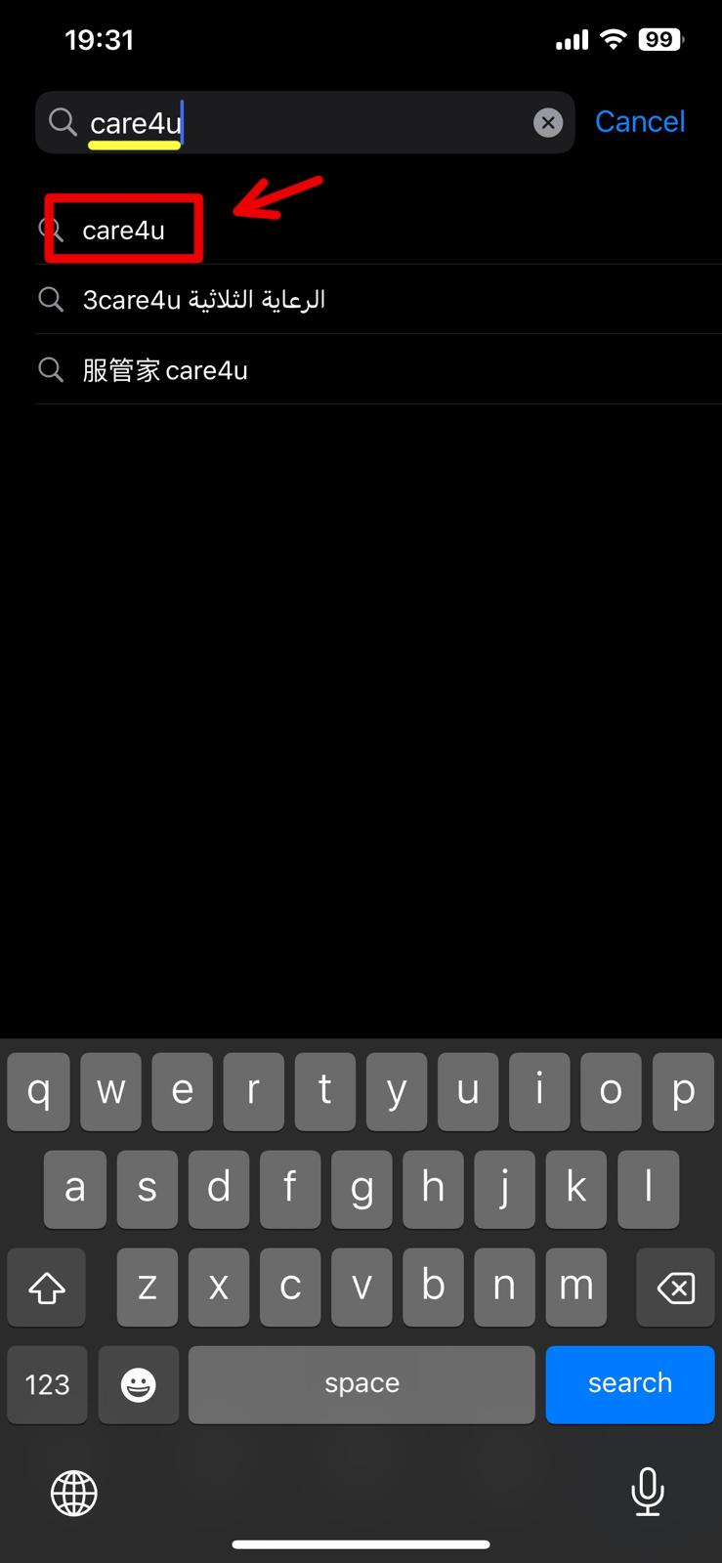
* Tap on “Get” and install the app.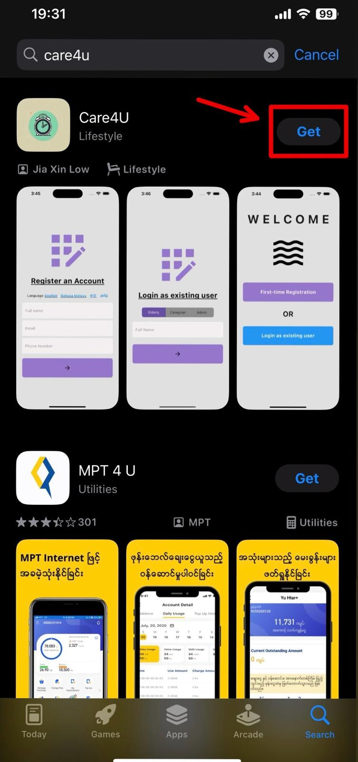

**For Android Users:**

* Open the Google Play Store.
* Search for “CareBuddy”.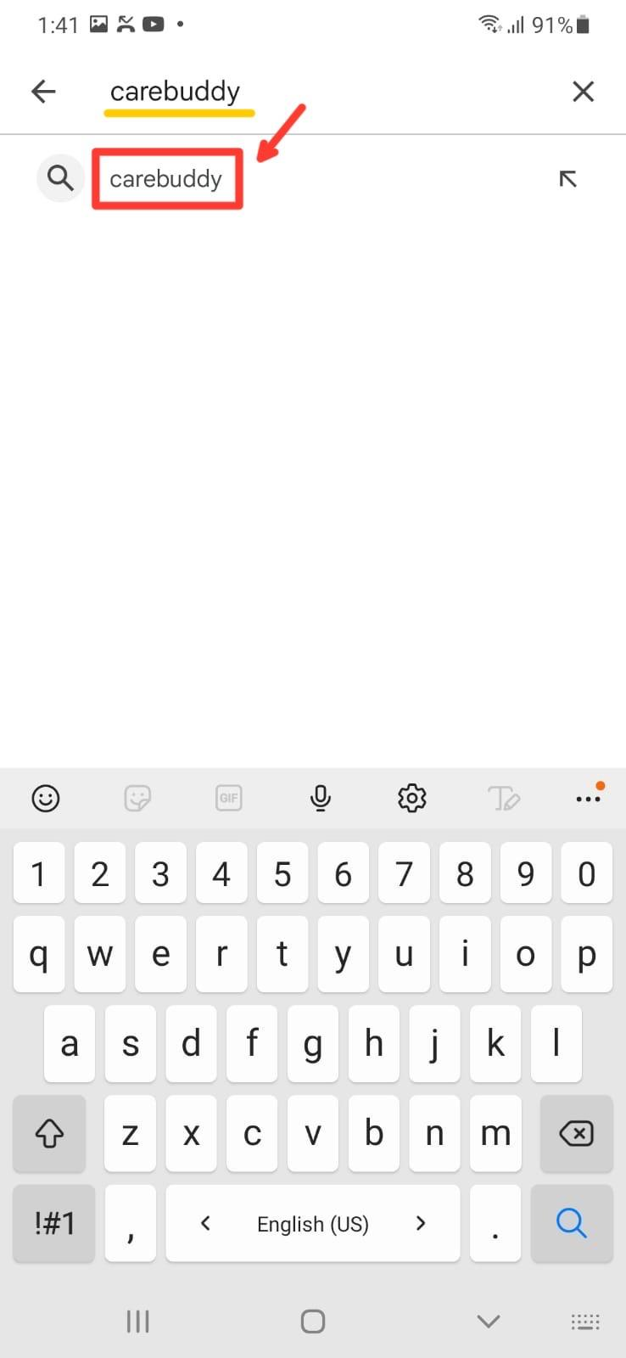

* Tap “Carebuddy” application, followed by “Install” to install the app.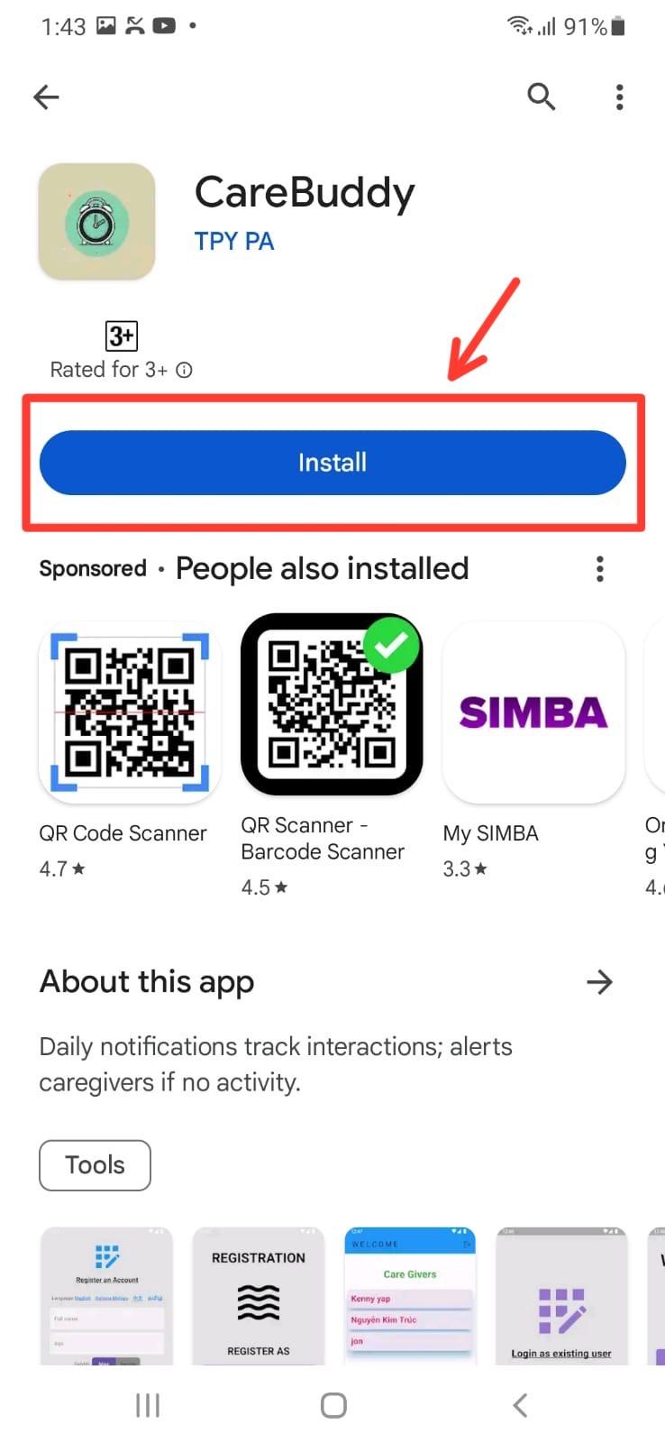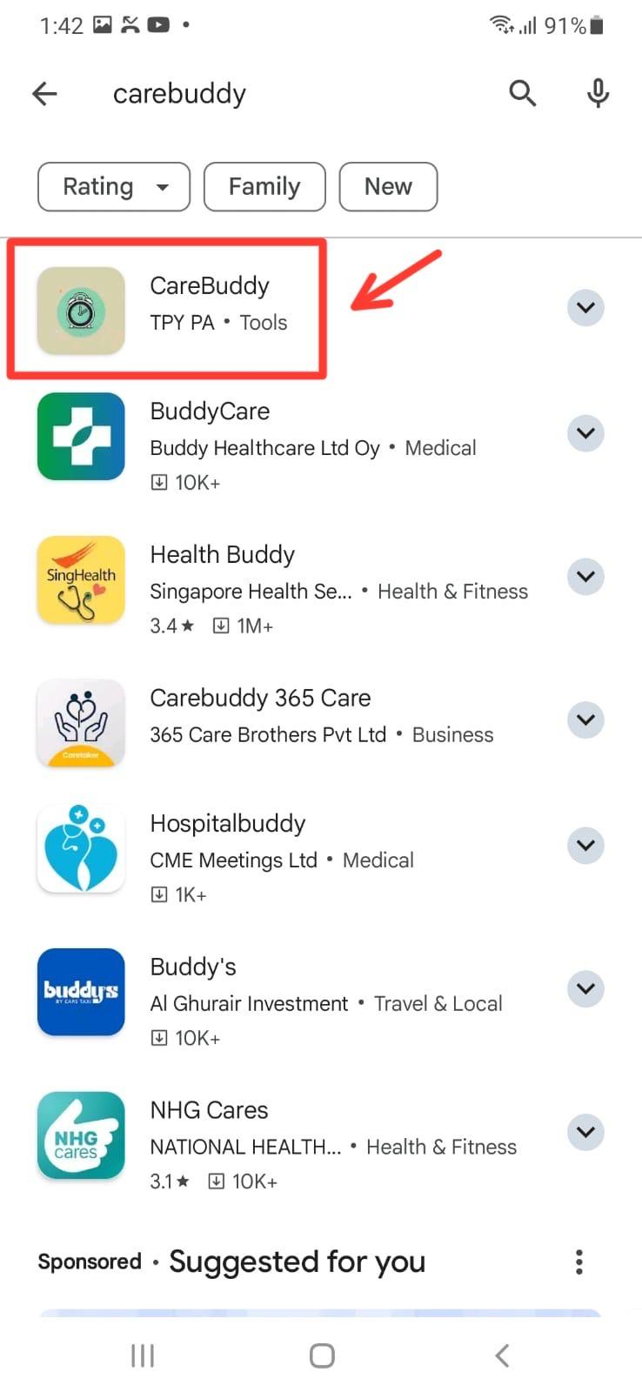

**App Features**

**1. Elderly**

* **Push Notifications (First-time users):**

**For Apple Users:**

* When you open the Care4U app, it will automatically prompt you if you would like to receive notifications.
* Click “Allow” to receive notifications.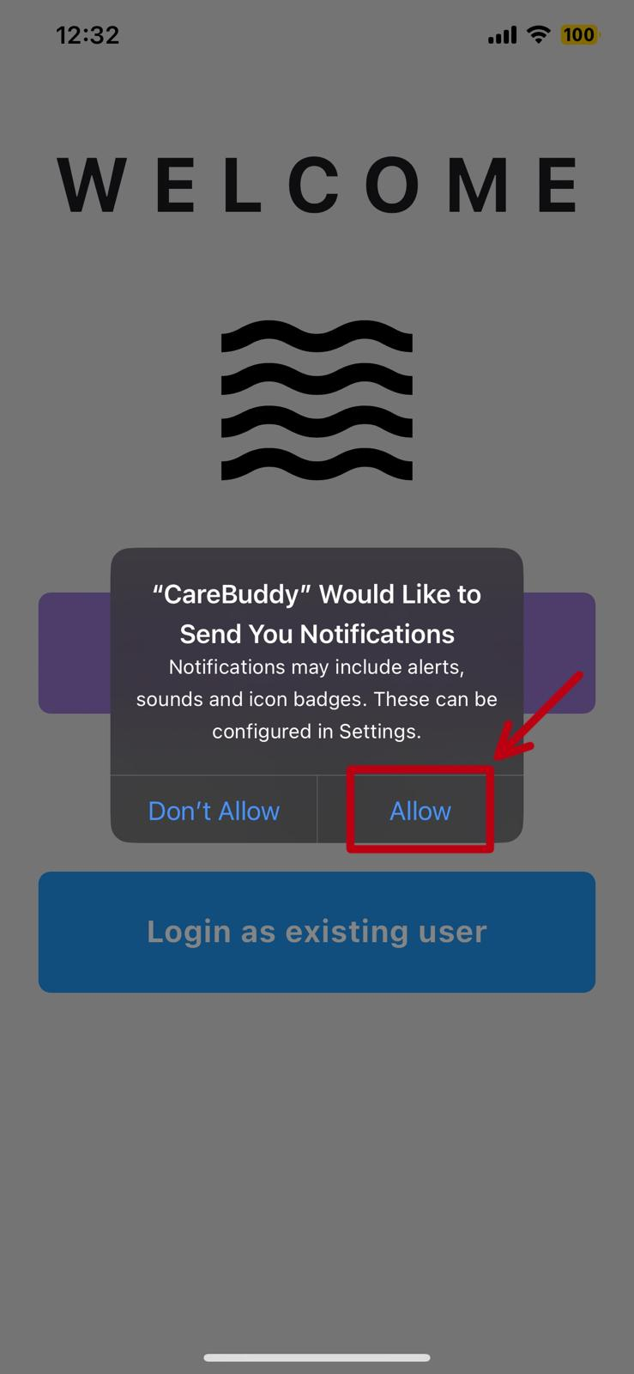

**For Android Users:**

Go to your phone “Settings” app.

* Navigate to the “Notifications” category.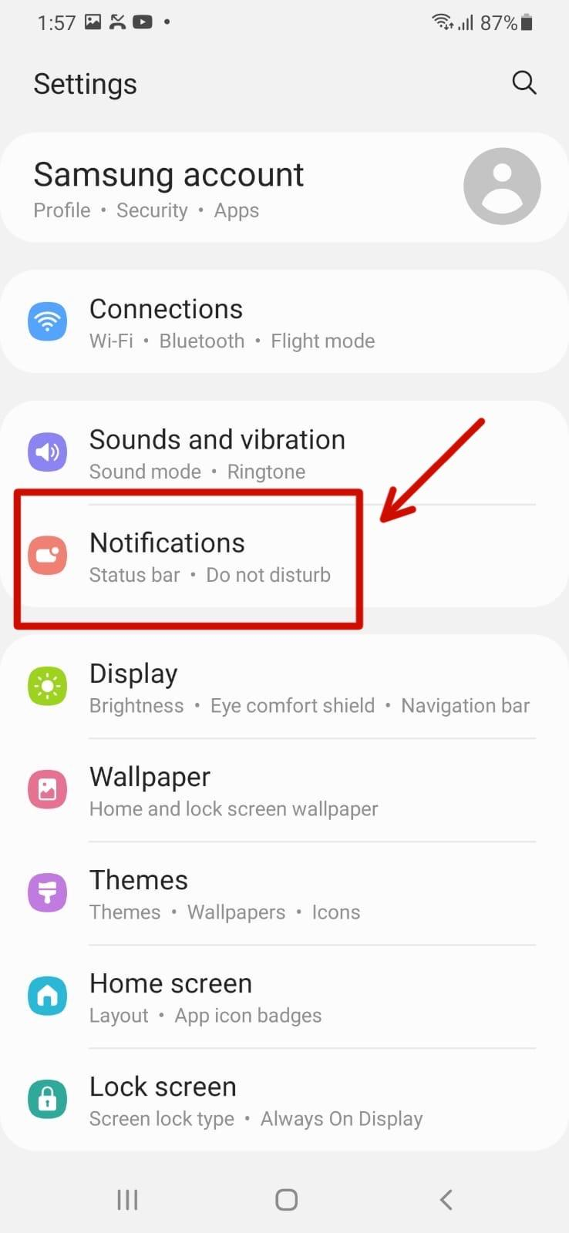
* Click on “Included Apps”.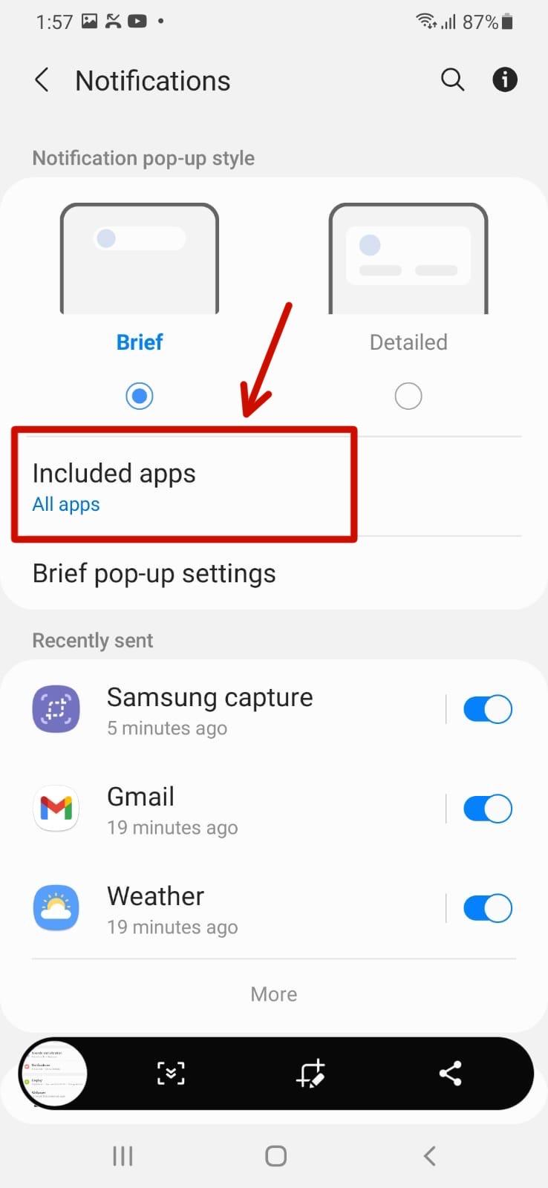
* Search for “CareBuddy”. Please ensure that the notification is turned on.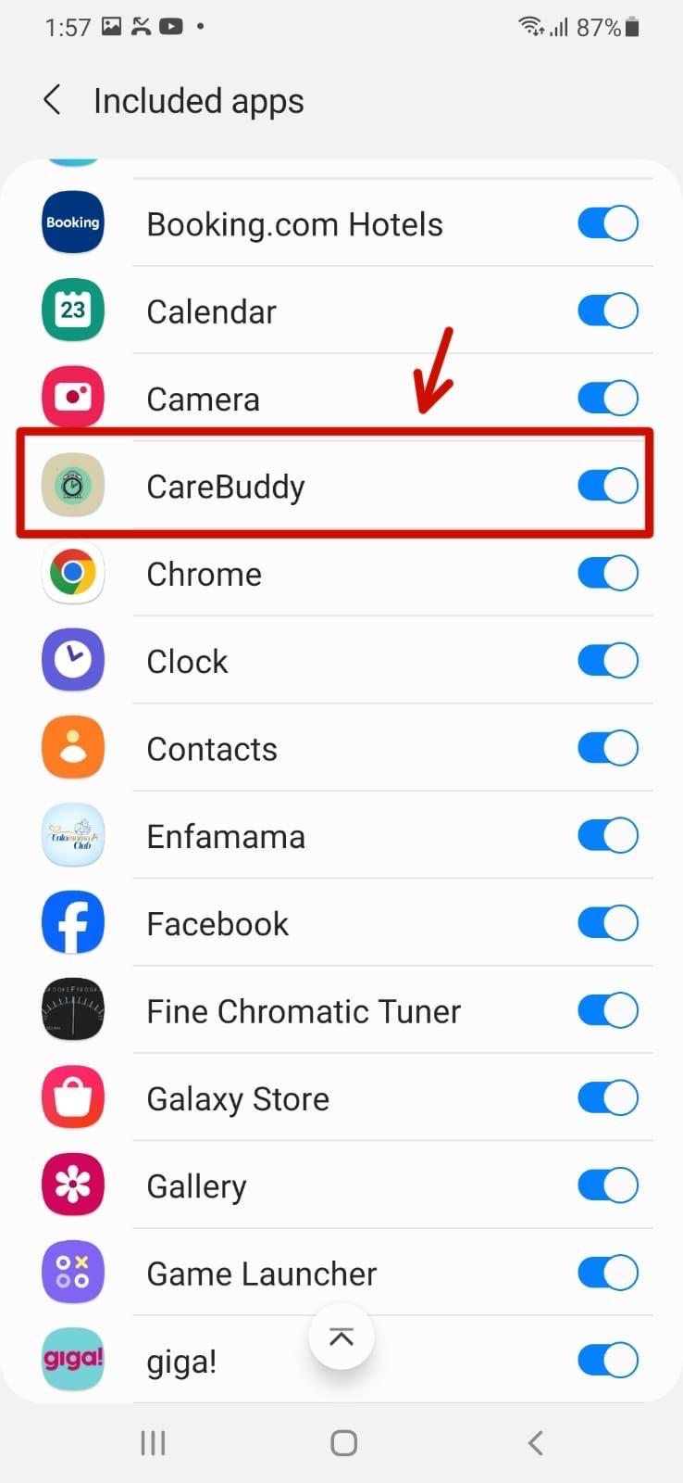
* **Internet Connectivity:**

***Note: You can only dismiss the alert box once you have internet connection.***

* You will not be able to proceed when you have no internet connection. Please ensure that you turned it on.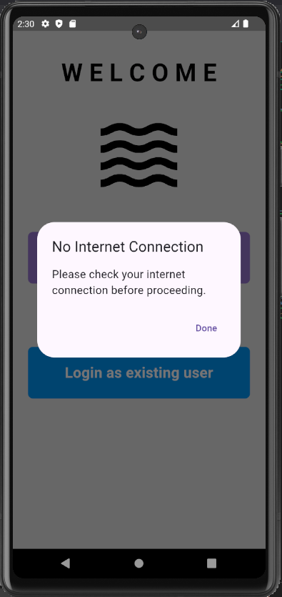
* **Registration:**
* Choose “First-time Registration” to register an account.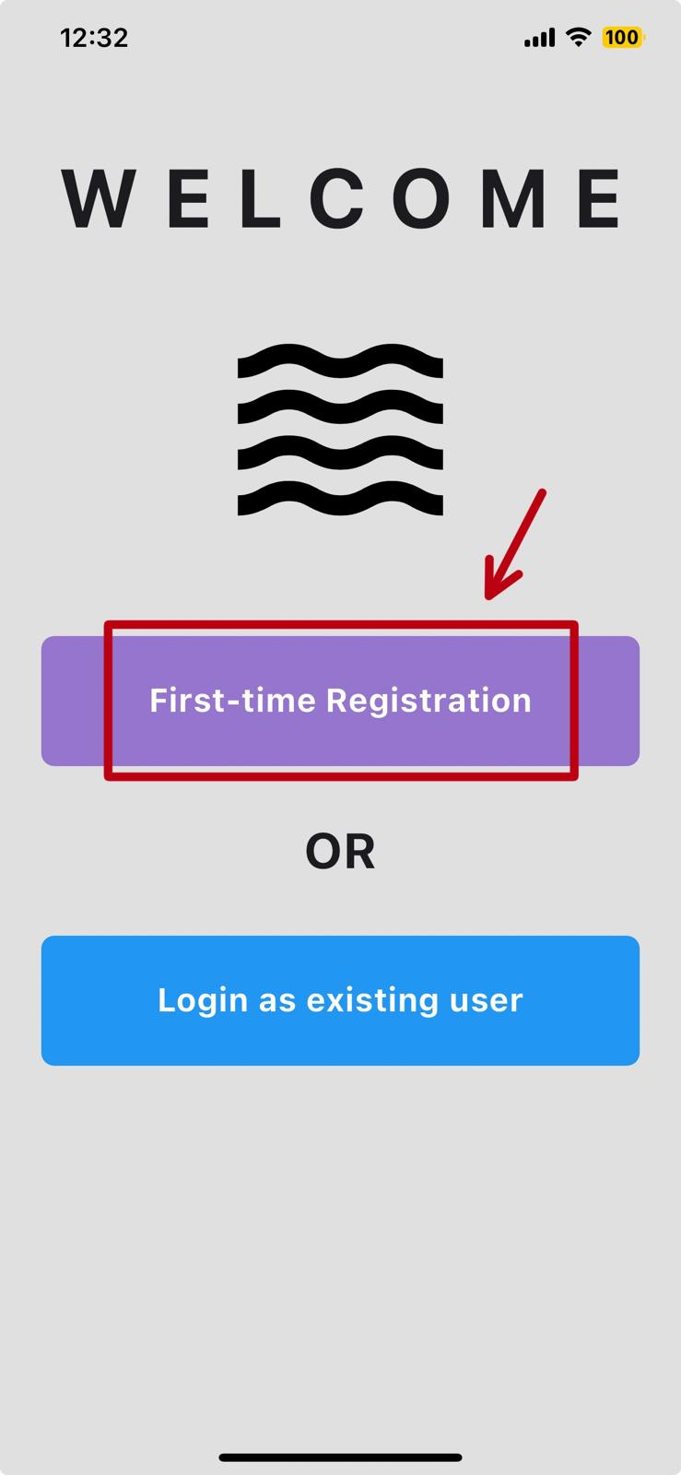
* Choose the “Elderly”.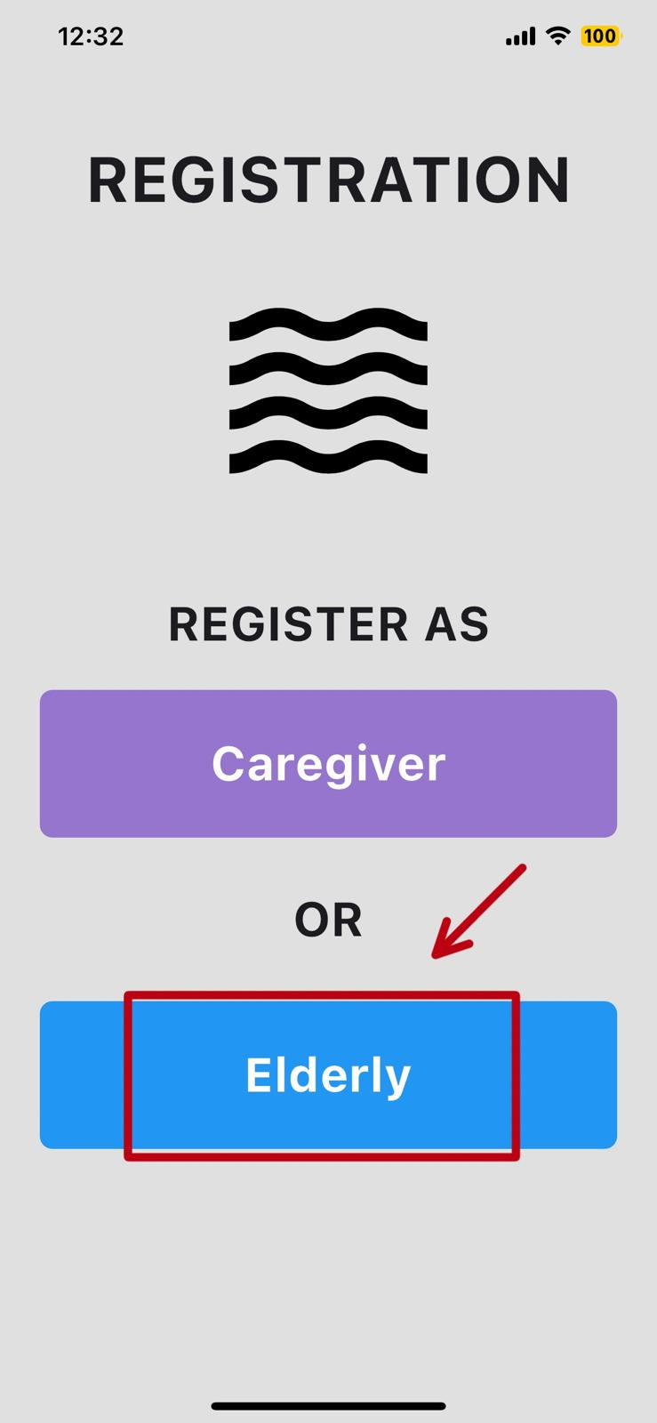
* Fill in your information details. (Choosable language)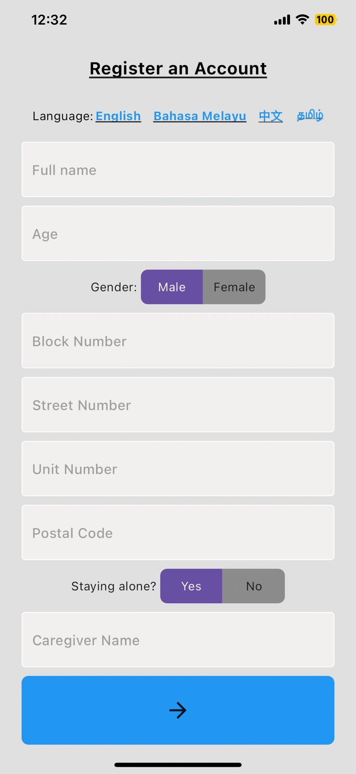
* **Login:**
* Choose “Login as existing user” to login your account.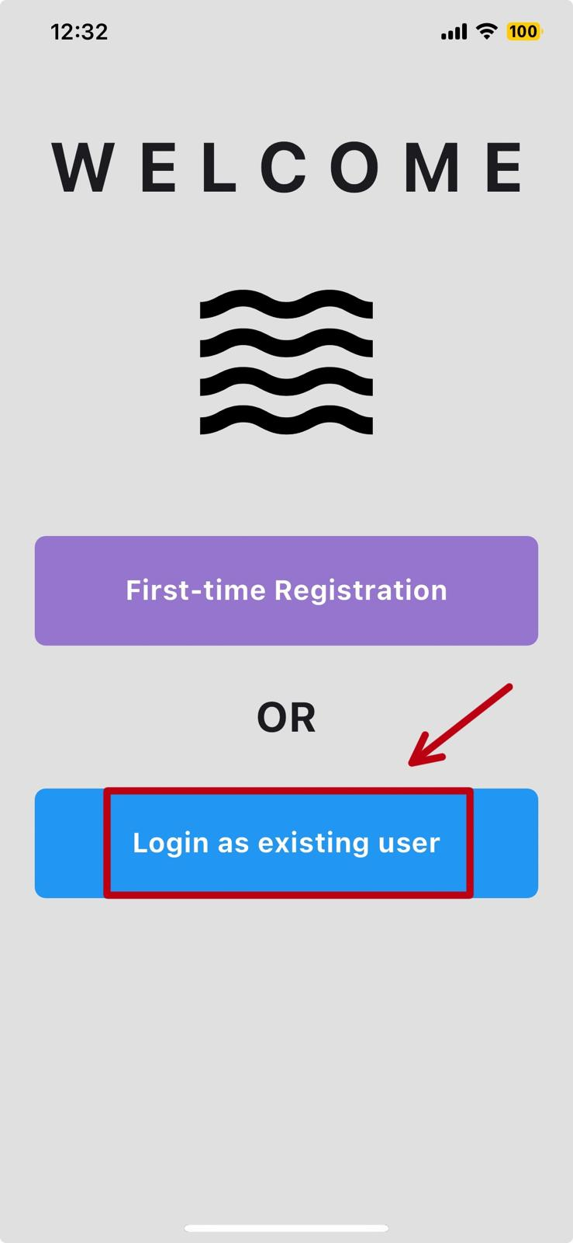
* Select the “Elderly” role and key in your registered name.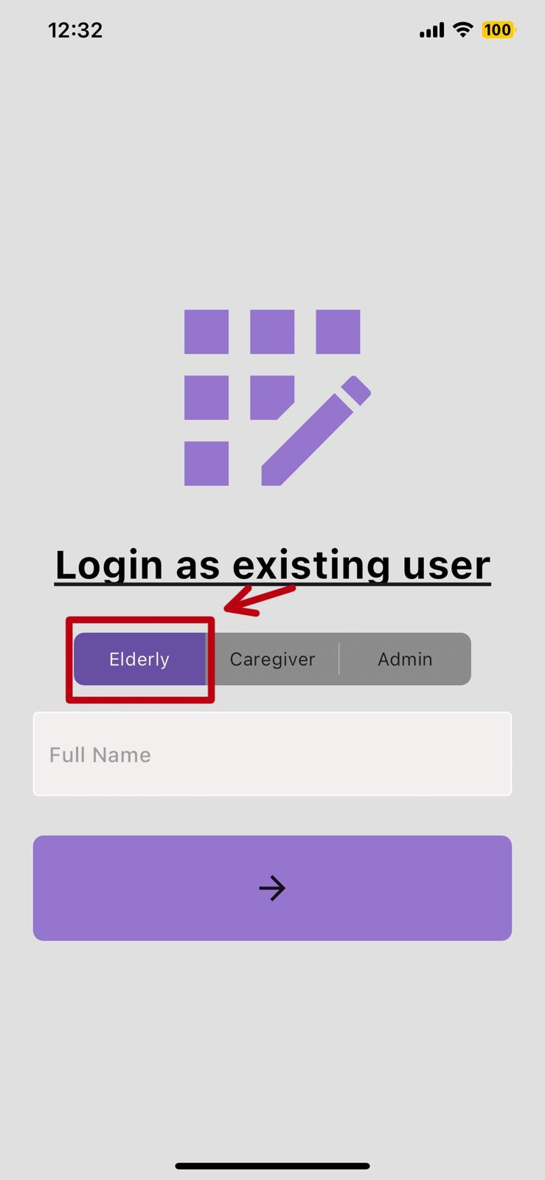
* **View Homepage:**
* This page will be directed to the elderly once they logged or registered their account.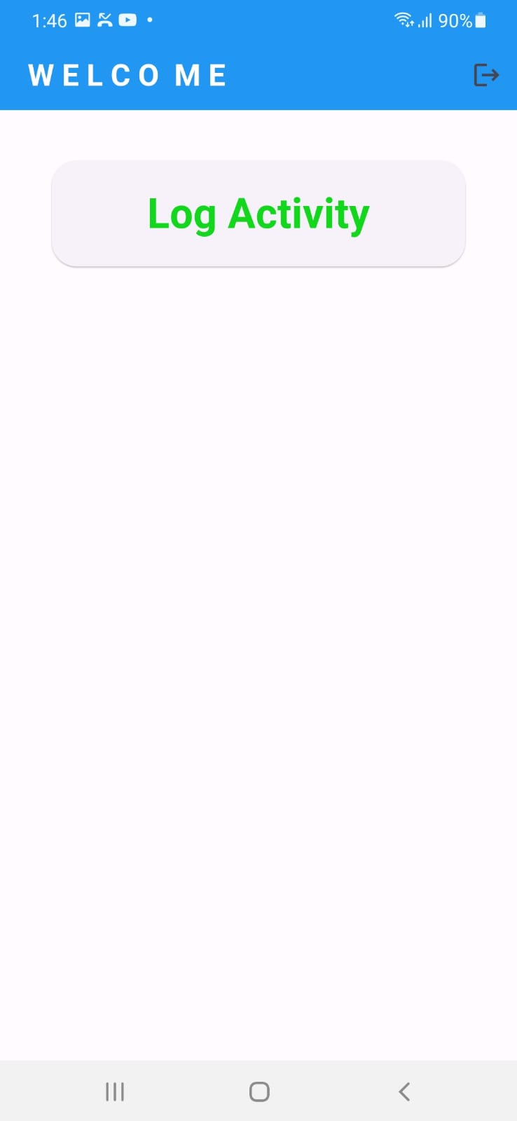
* **Manually Log Activity:**

An alert dialog box will be shown to the elderly that they had either logged in successfully or already logged in.

* Elderly clicked on the “Log Activity” to log activity. 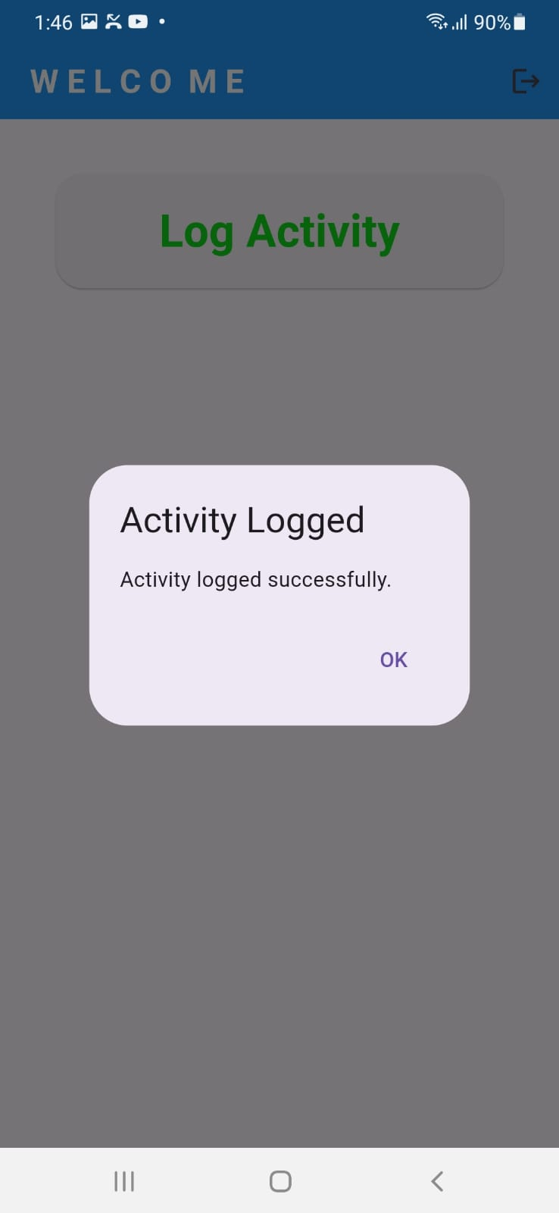
* When elderly clicked on the “Log Activity” to log activity again.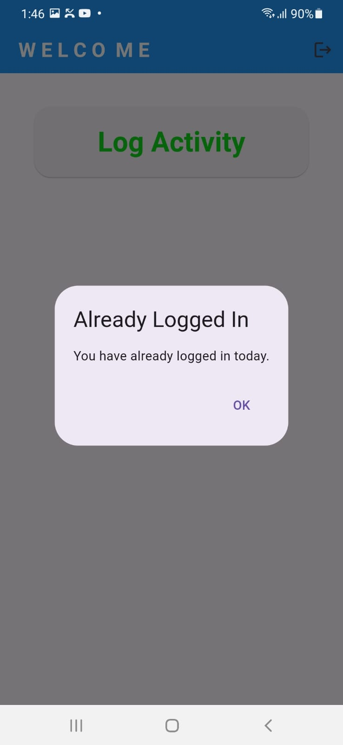

* **Alarm Rings:**
* The alarm will ring at 11am and 5pm to alert the elderly to log their activity if they have not done so.
* The elderly will then log into the app to log activity.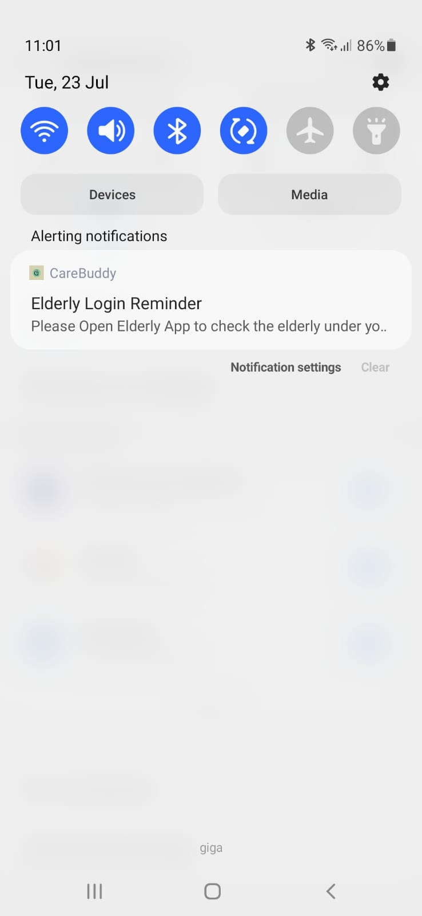

**2. Caregiver:**

* **Push Notifications**

**For Apple Users:**

* When you open the Care4U app, it will automatically prompt you if you would like to receive notifications.
* Click “Allow” to receive notifications.

**For Android Users:**

Go to your phone “Settings” app.

* Navigate to the “Notifications” category.
* Click on “Included Apps”.
* Search for “CareBuddy”. Please ensure that the notification is turned on.
* **Registration:**
* Choose “First-time Registration” to register an account.
* Choose the “Caregiver”.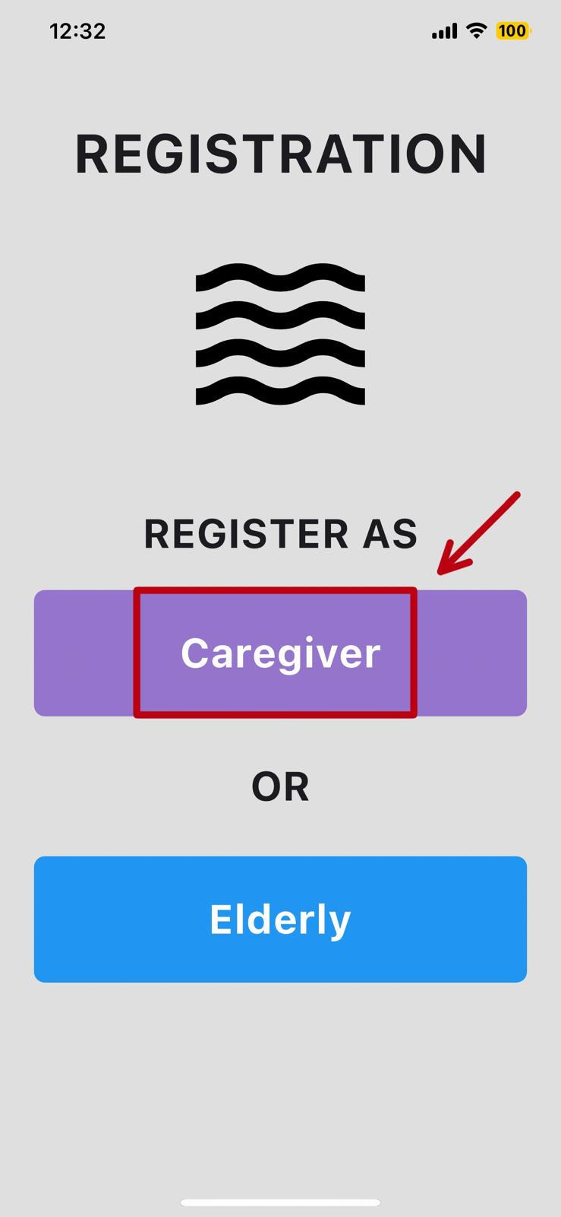

* Fill in your information details. (Choosable language)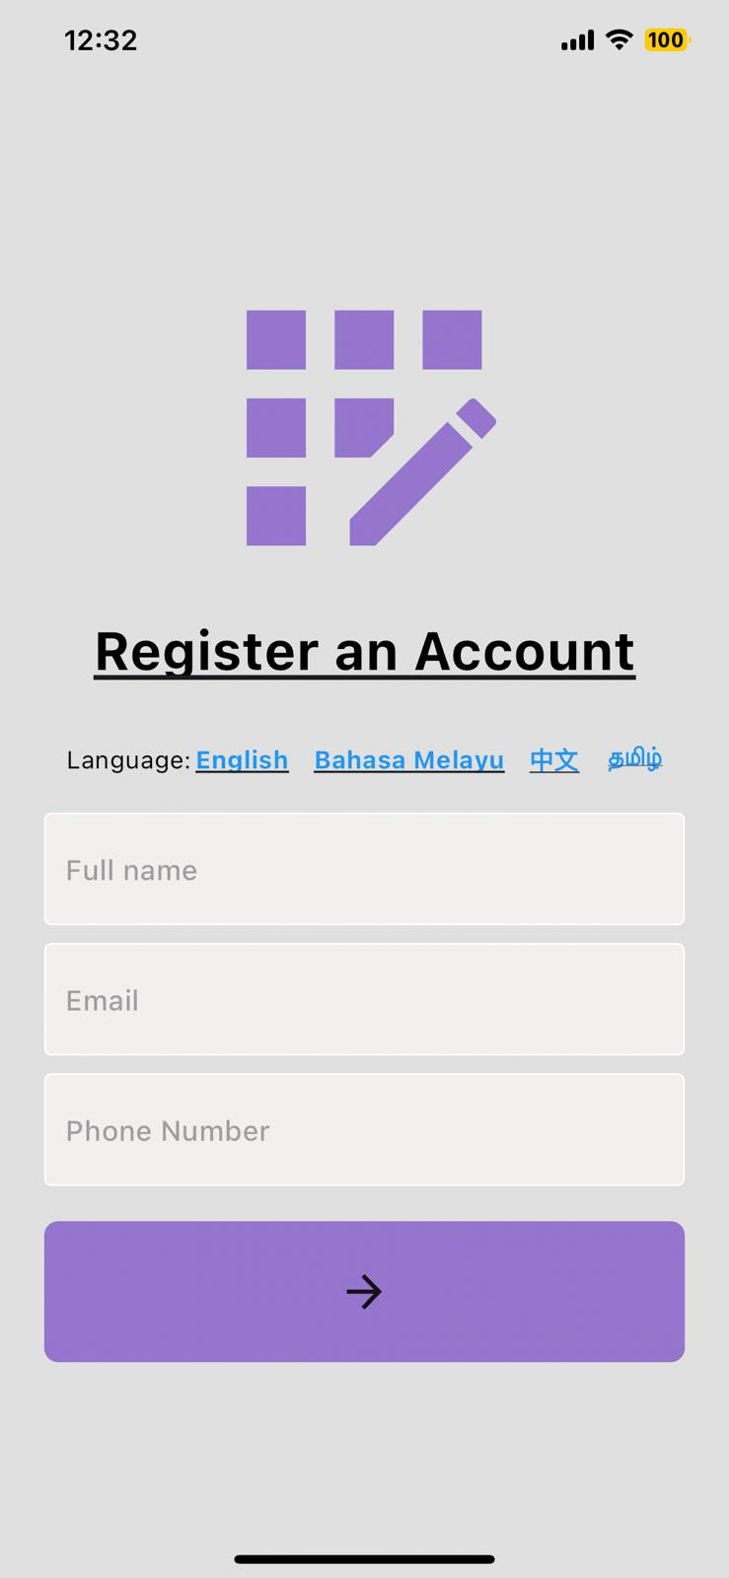
* **Login:**
* Choose “Login as existing user” to login your account.

* Select the “Caregiver” role and key in your registered name.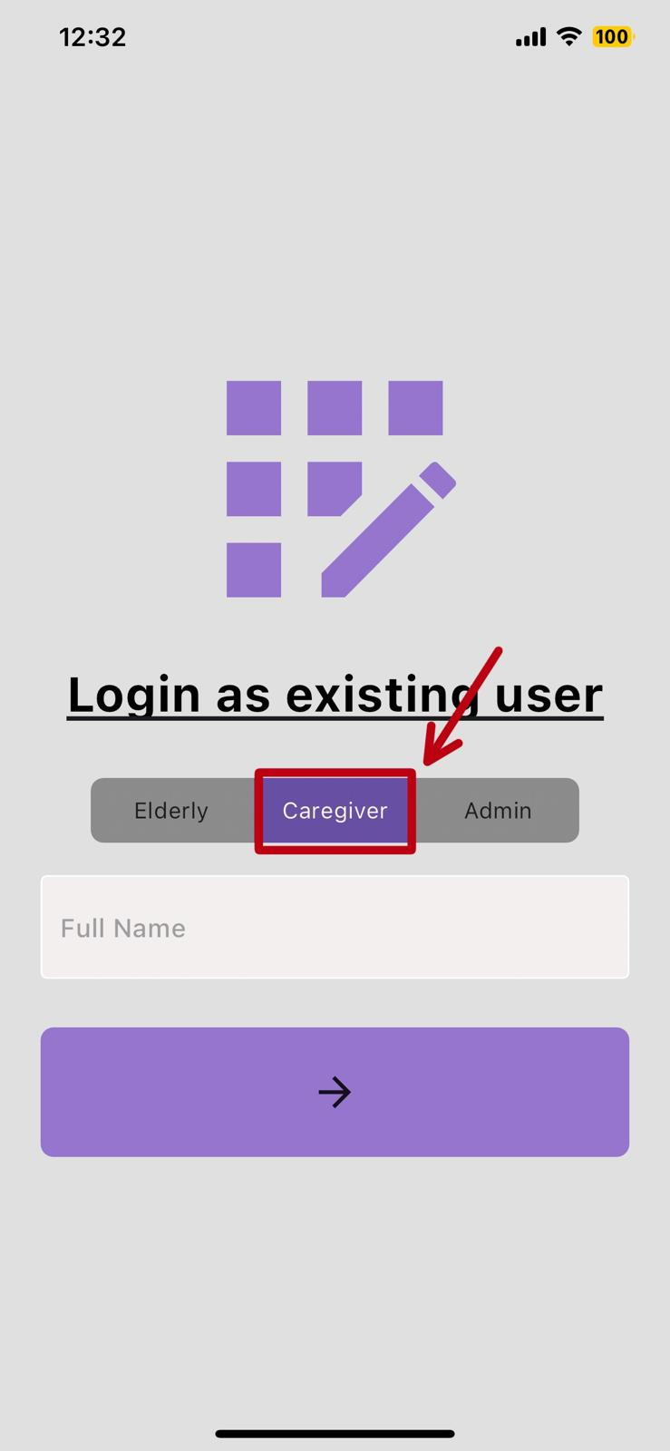

* **View Assigned Elderly (inclusive of Elderly Activity)**
* When elderly log activity, the status would show “Yes”.
* When elderly did not log activity, the status would show “No”.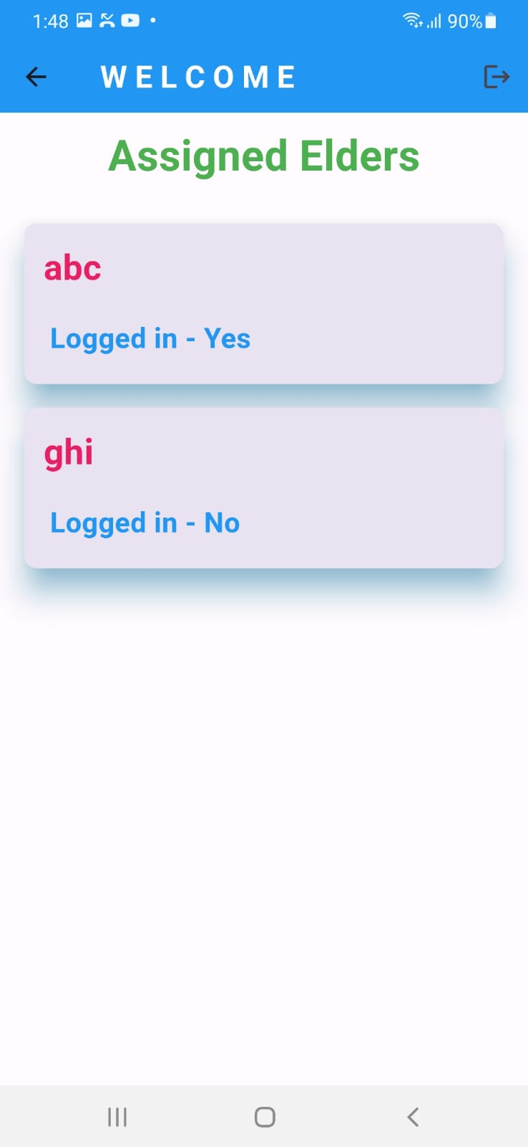

**3. Admin**

* **Login:**
* Choose “Login as existing user” to login your account.
* Select the “Admin” role and key in **“Admin”**.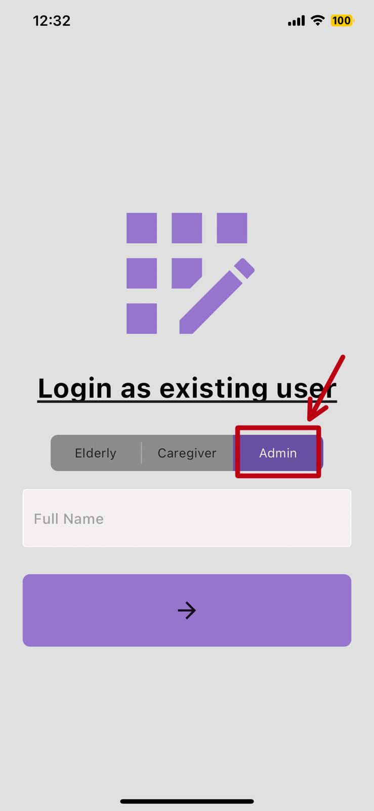
* Once logged in, the admin will be able to see all the caregivers' names.